Title: Does the type of cell matter when it comes to Biotechnology’s cell culture development?

Introduction:
Biotechnology is one of the largest and fasted growing science-based industries in North Carolina. In this lesson students will have an opportunity to research some different Biotech companies in North Carolina. Secondly, students will grow live yeast cultures to model the cell culture development essential to the success of biotech companies. Students will manipulate different limiting factors such as temperature and the amount of media to measure the impact on cell growth/viability. The third part of this lesson will have students graphing, performing data analysis, and comparative analysis to modeled-data from Biogen Idec’s cell culture development.

Learning Outcomes:

Students will:
- Research different Biotech companies in North Carolina including Biogen Idec for examples of their products, types of transgenic organisms used and their applications for bioscience (Pharmaceutical, Agricultural, Biofuels, etc…)
- make connections between the use of different types of cells such as bacteria, yeast, and mammalian cells to create many different products such as pharmaceuticals using biotechnology
- develop hypotheses as to how temperature and media concentration can independently affect the rate of growth for yeast cells
- learn the importance of and use of sterilization (aseptic) techniques when growing cell cultures
- conduct and set up and an experiment to measure the number of yeast cells grown when changing the amount of media and temperatures at which the yeast cells are exposed
- learn how to count cells using a hemocytometer
- calculate daily the number of cells/mL (using significant digits) for each of the control and experimental yeast cell cultures set ups over a 4 day period
- create exponential graphs plotting the number of cells/mL calculated over time (one for temperature and one for media concentration)
- interpret and analyze the data from the graphs to draw conclusions with regards to the impact of limiting factors on cell growth
- learn the importance of cell culture development for the biotech industry.
- compare and contrast mammalian (Biogen) and Yeast cell culture developments.

Curriculum Alignment:
Bio.1.1.2 Compare prokaryotic and eukaryotic cells in terms of their general structures (plasma membrane and genetic material) and degree of complexity
Bio.1.2.3 Explain how specific cell adaptations help cells survive in particular environments (focus on unicellular organisms).
Bio.1.2.1 Explain how homeostasis is maintained in a cell and within an organism in various environments (including temperature and pH).
Bio.3.3.2 Summarize how transgenic organisms are engineered to benefit society.

Classroom Time Required:
Day | Activity | Time Required
1 | Inquiry into NC Biotech Companies | 40 mins *
2 | Experiment -Set up Yeast Cell Cultures and Collecting Baseline Data | 40 mins
3 | Collecting Data (Cell counting) | 20 mins
4 | Collecting Data (Cell counting) | 20 mins
5 | Collecting Data (cell Counting) | 20 mins
6 | Graphing and Data Analysis | 30 mins
7 | Lab Report Conclusions and Comparisons to Mammalian Cell Cultures Data | 40 mins
*This part of the assignment can be completed outside of class to save time

Materials Needed:

Activity One: Researching NC’s Biotech Companies
Equipment/Supplies/Handouts | Quantity/Notes
Computer/ Internet Access* | One per Group (2-4 students)
NC’s Biotech companies handout/worksheet | One per Student or Group ( teachers can have the option of having each student complete the worksheet or designate one student to record all the information within a group)
Pen/Pencil | One per Student or Group
*Teachers with limited internet access or computers etc… can look up information about the companies in advance and print out information to supply each group
Activity Two: Yeast Cell Culture Growth
Most materials/equipment can be bought and/or supplied by either Carolina Biological and/or Flinn Scientific unless otherwise noted
Equipment | Quantity/Notes
Lab coat/Apron | One per student
Goggles/Safety Glasses | One per student
Safety Gloves | Pair per Student (non-latex are preferred due to potential student allergies)
Sharpie | One per group ( Groups of 2-4 Students) to label test tubes
Paper Towels or Non-linting tissues | One roll/box per group
70% Ethanol Solution In Spray bottle | One per group
Test Tubes (large enough to hold at least 10mL) | 3 per group
Test Tube Racks | One per group
Compound Light Microscopes | One per group
Plastic Sterile pipettes (1-10mL) | One per group
Micro Pipettes ( 10-100 microLiters)* with sterile disposable tips | One pipette per group and approx. 250 sterile tips per class
Scale (electronic or triple beam) | One per class ( or one per group if students are preparing their own yeast growth media)
Baker’s yeast ~Saccharomyces cerevisiae | ½ g per group ( ½ g per 50mL of water) Red Star® Active Dry Yeast was used for this experiment and bought at Whole foods, but generic Active Yeast packets are available in the baking section of any grocery store)
Water (warm) | 100 mL per class
Water (Rm temperature) | 500 mL per class
Beaker or flask (250 mL) | One per class to prepare the yeast broth
Beaker or flask (1000 mL) | One per class to prepare the yeast media
Glass Stirring Rod | Two per class to stir yeast broth and media
Microwave or Hot Plate (with magnetic stirrer) | To warm the water for yeast broth and hot plate with magnetic stirrer is needed to prepare yeast media
Trypan Blue Stain or Methylene Blue | 0.5% Solution Concentration in dropper bottles / One per group
Thermometers | 3 per Class (one in Incubator, one for room temperature, and one in refrigerator)
Refrigerator | One per class
Incubator | One per class (set at 30C for optimal yeast growth)
Hemocytometer | One per group (cheap ones can be purchased thru various online shopping sites such as Science Lab Supplies and Amazon)
Cover Slips | One per group
1.5 mL Microcentrifuge Tubes | 3 per group (can be cleaned and reused each day)
Dextrose | 10g per 500 mL of growth media (or can be substituted using corn syrup, molasses or other sugar sources than table sugar)
Yeast Extract | 5g per 500 mL of growth media (Marmite Yeast Extract can be bought a health food stores such as whole foods or can be substituted using Wyler’s reduced- sodium bouillon cubes which are available at any grocery store)
Peptone | 10g per 500 mL of growth media
*Sterile droppers can be used in place of micropipettes

Optional Equipment:
-Autoclave, Vortex, microscope cameras, cell counting slides (Cellometer, or grid slide)

Classroom Set-Up:
The class can be set up in lab stations with materials already distributed to each group (2-4 students) or equipment can be set up in a central location for students to pick up and move to their lab station as needed.
Activity Three: Data Analysis and Case Study
Equipment/Supplies/Handouts | Quantities/Notes
Cell Culture Lab Sheets to record Data and complete discussion questions | One per student or group
Colored pencils, pens or markers | 3-5 Different colors per student or group
Case Study Graphs (Biogen Data) | One per student or group

Optional Equipment:
Computers (Students can use excel to generate spreadsheets for recording and analyzing data and generating graphs)

Technology Resources:
Students will use a variety of Biotechnology equipment such as microscopes, hemocytometers, micropipettes, and incubators. Depending on availability, some activities will require students to use computers for internet research, generating spreadsheets to track and analyze data from the experiment. A computer hooked up to an LCD projector can also be used to help the teacher extend the lesson to incorporate power point presentations and videos.

Pre-activities:
Before completing these activities, students should already familiar with how to use a microscope, the key structures/organelles of different types of cells (incl. fungi), the concept of homeostasis, the methods of cell reproduction and the process of genetic engineering and recombinant DNA to create transgenic organisms. These are all key concepts within the essential standards and would/should be taught before considering this lesson. Teachers should also be familiar with sterilization techniques, how to set up basic lab materials and how to use a hemocytometer. Teachers can refer to the websites and references below for additional preparation.
Activity One: Researching NC’s Biotech Companies
Teacher Preparation:
- Have computers with internet access ready or information with regards to different NC BioTech companies printed out for students to use. This however; would require additional prep time and research on part of the teacher.
- Copy NC’s Biotech Companies handout
Activity Two: Yeast Cell Culture Growth
Teacher Preparation
- Get all materials needed (see materials list). Materials and equipment can be either set up as lab stations for each group (2-4 students) or in a central location for students to move to their lab stations.
- Prepare Yeast Broth and Media
Yeast Broth (to be prepared in 250 mL beaker or flask)
-½ g of Baker’s Yeast per 25 mL of warm water per group
(8 groups = 4 grams +100mL of warm water)

Yeast (YPD) Media (to be prepared in 1000 mL beaker or flask)

-5 g of yeast extract (marmite)
-10g of peptone
-10g of dextrose
-500 mL of water

*use a hot plate with magnetic stirrer to boil all powders until they are completely dissolved. Allow the media to cool down to room temperature before use.

- Create 70% Ethanol Solution Into spray bottles
- Create 0.5% Methylene Blue Solution or Trypan Blue Stain Solution into dropper bottles
- Copy Cell Culture Lab handouts for students
Activity Three: Data Analysis and Case Study
- Copies of Cell Culture Lab handouts for students
- Required graphing materials (Colored pencils, pens or markers) or Computers with excel
- Print out or provide access to Case Study Graphs (Biogen Data)

Activities:

Activity One (Day 1): Researching NC’s Biotech Companies
- Provide students with the researching NC’s Biotech Companies hand out
- If computers are available, be sure that internet access is working or have printed out information with regards to each of the companies for each group.
- Have students complete Part A - Key Terms/Vocabulary before doing any research.
- Have students complete Part B - Researching NC Biotech Companies using The North Carolina Biotechnology Center’s website: http://www.ncbiotech.org/ . Encourage students to also use other sites such as the companies’ websites to also collect information. Note: teachers can pair students to work in groups (2-4) students, can change the number of Biotech companies or even change the actual Biotech Companies to look up. (Ex: A local biotech company may be profiled)
- Have students individually complete Part C – Discussion Questions included on the handout and then discuss as a class different possible answers. The discussion should also help students to link prior knowledge of cell structures, adaptations, etc… of bacterial, yeast, plant and animal cells to their current use in Biotechnology. A further discussion can include which companies would students potentially like to work for, what kinds of skills they might need to work there, etc…

Activity Two (Days 2-5): Yeast Cell Culture Growth
- Provide students with the Yeast Cell Culture Lab Sheet hand out
- Have students read over the Lab Sheet and pay close attention to the background information, leading/pre-lab questions and the overall set up and procedure.
- Generate a class discussion to address the leading questions on the Yeast Cell culture Lab sheet hand out. During the discussion the concept of homeostasis can be reviewed. This should help students to focus on how the limiting factors which will be manipulated in the experiment might impact the overall growth of the yeast cells and developing their hypotheses. Students can also be asked to answer the leading/pre-lab questions as part of their lab write up rather than just be discussed as a group.
- Have students develop and write down their hypothesis for the experiment on the lab sheet handout
- Review the overall procedure with students (Parts A, B, and C)

Note: if this the first time students will be setting up cell cultures the teacher may want to perform a demonstration on how to use the different equipment (micro pipettes and hemocytometer), set up the samples, and review aseptic techniques. See the Supplemental and Additional Resources section of this lesson for additional help with these procedures if needed.

- Have students set up the experiment as outlined in Part A of the procedure on the lab handout.

Notes:
-equipment and materials should have been prepared in advance (see pre-activities section)
- Each group could test for both by setting up 5 test tubes to test both variables at once
(test tubes 1-3 for temp and then 2 and 3 for media)

- Students should complete Part B – Counting cells with a Hemocytometer and record their data (number of cells/mL) in the tables on the Lab Sheet handout.

Notes:
-Groups testing different variables can be paired up to share their data collected and complete both tables
-Teachers may also want to discuss with students the importance of using Significant Digits to record their data (ease of recording data and consistency of measurement from group to group or scientist to scientist)

- Students should then follow the procedures as outlined in Part C by making and recording qualitative observations (see lab sheet for examples) with regards to the yeast cell culture solution into the data tables on the Lab Sheet handout
- Have students place appropriate test tubes with the remaining yeast cell culture solution into proper locations for 24 hr intervals.
- Students should count cells and collect data over the following 4 days (Repeat Part B and C)
- As students perform their experiments they should also keep track of any possible errors or mistakes that may have occurred and explain how it may have impacted the yeast growth onto Part D of the Lab handout.
- At the conclusion of the experiment on the 5th day, students should clean up and dispose of their yeast cell cultures

Note: Yeast cell cultures are non-toxic or hazardous but should be sterilized before being poured down the drain or flushed down the toilet. Sterilization can typically be done by pouring the yeast solution into a bucket containing a bleach-water solution (1:4 dilution) and allowing it to sit overnight.
Activity Three (Days 6-7): Data Analysis and Case Study
- Students using either graph paper or a computer should plot the data collected from both variables tested and collected in their data tables for part A. Since two different variables were tested, two different graphs should be generated. Temperature and Concentration of media represent the independent variables and should be plotted onto the x-axis. The number of cells/mL represents the dependent variable and should be plotted on the y-axis. Note: it’s important to stress to students the importance of labeling their axis, the use of units, equal intervals, and creating a title for each graph.
- Have students from different groups compare and contrast their graphs. They should look for similar patterns in the graphs and discuss what might account for possible differences in their data/graphs.
- Have students write a conclusion for part B summarizing the purpose of the experiment, results of the experiment, possible errors and make connections between how the different limiting factors overall influenced the number of cells/mL based on their data.
- Provide students with the graphs generated from the mammalian cell cultures at Biogen Idec. Note: due to confidentiality and intellectual property rights the units and drug product were not provided. However, this would be a good opportunity to discuss with students what would be considered reasonable ranges of units which could be generated based on their data and observations.
- The graphs supplied by Biogen Idec measure other limiting factors such as pH, CO₂, O₂, and Glucose levels on mammalian cell cultures. Have students complete the questions individually in part C and then discuss together with students why each of these other limiting factors have or could impact the growth of yeast cell cultures. Note: References to Cellular respiration and homeostasis can be made and reviewed in the discussion.

Assessment:
-both informal (teacher questioning and checks for understanding – teachers can use the specific questions provided in the lab handouts which also allow for guided practice before formal/summative assessments are provided) and formal forms of questioning (worksheets, questions in subsequent tests and quizzes)
-Students sharing their findings with regards to their research about NC Biotech companies
-class discussions
-student lab reports (including: leading/pre-lab questions, hypothesis, data tables, graphs, and guided questions to draw conclusions)

Note: since answers will vary for most of the questions contained within the handouts and the data collected from the experiment no rubrics or answer keys can be provided. Teachers can generate a grading rubric for the lab-report should they assign this for a grade.

Modifications:
-Activity one can be done outside of class time as a homework assignment to limit the amount of time spend in class
-all handouts, websites, videos can be linked onto a website or school server for students to have access to and work on outside of class.
-Students can work together as a group (teachers can devise groups to mix diverse learners) to prepare one lab report as a power point, poster, etc… where students can divide up tasks based on strengths.
-teacher can set up and perform the yeast culture experiment as a demo to cut down on class time or if supplies are limited

Supplemental Information/Resources:
Videos:

1. “Heal, Feed, Sustain: How Biotechnology Can Help Save the World “ http://vimeo.com/17125052
– 23 mins, hosted and narrated by middle school students while visiting different biotech companies in NC. North Carolina Association for Biomedical Research
2. “Animal Biotechnology – The Movie” http://animalscience.ucdavis.edu/animalbiotech/
-30 mins video, covers various topics related to animal biotechnology. University of California, Davis

Possible Extensions:

1. Exploration in to the BioSciences Workforce and Education
-Using the Biotech Career Guide (link) on the NC Biotech website (www.NCbiotech.org) students can explore one or several of the basic careers in Bioscience. It also provides information on what types of High School courses students should take in addition to NC College Program information and Sample job titles. Teachers can have students make posters or do a mini presentation on the different careers.
2. Schedule Field Trips or have guest speakers from some of the different local Biotech Companies
Background Reading:
For additional Information and resources visit the websites mentioned below

Critical Vocabulary:
TERM | DEFINITION
Biotechnology | 1. A set of biological techniques developed through basic research and now applied to research and product development. Biotechnology refers to the use of recombinant DNA, cell fusion and new bioprocessing techniques. 2. Any technological application that uses biological systems, living organisms or derivatives thereof to make or modify products or processes for specific use. 3. The industrial use of living organisms or biological techniques developed through basic research. Biotechnology products include antibiotics, beer, cheese, insulin, interferon, recombinant DNA and techniques such as waste recycling.
Genetic Engineering | The technique of removing, modifying or adding genes to a DNA molecule to change the information it contains. By altering this information, genetic engineering changes the type or amount of proteins an organism is capable of producing, thus enabling it to make new substances or to perform new functions. It is done to eliminate undesirable characteristics or to produce desirable new ones.
Genetic Modification | 1. The production of heritable improvements in plants or animals for specific uses, via either genetic engineering or other, more traditional methods. 2. Any process that alters the genetic material of living organism.
Genetically Modified Organism/ Transgenic Organism | The label GMO and the term transgenic often refer to organisms that have acquired novel genes from other organisms by laboratory gene transfer methods. GMOs have had genes from other species inserted into their genome.
Pharmaceutical Biotechnology/Pharming | 1. The process of farming genetically engineered plants or animals to be used as living pharmaceutical factories. The practice has used cows, sheep, pigs, goats, rabbits and mice to produce large amounts of human proteins in their milk. Plants are being used to produce vaccines and diagnostic reagents. 2. The production of pharmaceuticals from genetically altered plants or animals.
Biofuels | Fuels made from biomass resources or their processing and conversion derivatives. Biofuels include ethanol, biodiesel and methanol.
Agricultural Biotechnology | A range of tools, including traditional breeding techniques that alter living organisms or parts of organisms to make or modify products, improve plants or animals or develop microorganisms for specific agricultural uses. Modern biotechnology includes the tools of genetic engineering.
Cell Culture | A method for growing cells in the laboratory
Media | Substance containing nutrients needed for cell growth
Inoculate | To introduce a microbe into an environment in which it can grow
Sterile/Aseptic Techniques | Laboratory procedures used in handling cultures, media and equipment to prevent contamination
Cell Viability | measure of cells that are alive
Bioreactor | An apparatus, such as a large fermentation chamber, for growing organisms such as bacteria or yeast that are used in the biotechnological production of substances such as pharmaceuticals, antibodies, or vaccines, or for the bioconversion of organic waste
Trypan Blue | is a dye used to measure cell viability. Since mitochondria are very selective in the compounds that pass through the membrane, in a viable cell trypan blue is not absorbed, however, it traverses the membrane in a dead cell. Hence, dead cells are shown as a distinctive blue color under a microscope
Methylene Blue | Stain like Trypan Blue that is often used to determine if cells are alive or dead. Lighter or opaque stained cells are alive as they are able to metabolize the stain. Dark blue cells would be dead as they can con longer metabolize the stain.
Limiting Factors | A factor present in an environment that controls a process, particularly the growth, abundance or distribution of a population of an organism. (examples include pH, Temperature, availability of food/nutrients)
Homeostasis | The tendency of an organism or cell to regulate its internal conditions, such as the chemical composition of its body fluids, so as to maintain health and functioning, regardless of outside conditions. The organism or cell maintains homeostasis by monitoring its internal conditions and responding appropriately when these conditions deviate from their optimal state.
Dextrose | A sugar that is the most common form of glucose. It is found in plant and animal tissues and also derived from starch. Dextrose is the dextrorotatory form of glucose
Incubator | An apparatus in which environmental conditions, such as temperature and humidity, can be controlled, often used for growing bacterial cultures, hatching eggs artificially, or providing suitable conditions for a chemical or biological reaction.
Hemocytometer | is a device originally designed for the counting of blood cells. It is now also used to count other types of cells as well as other microscopic particles
Peptone | A soluble protein formed in the early stage of protein breakdown during digestion which can be used in liquid mediums to grow bacteria and yeast
Vaccine | A preparation of a weakened or killed pathogen, such as a bacterium or virus, or of a portion of the pathogen's structure that upon administration stimulates antibody production or cellular immunity against the pathogen but is incapable of causing severe infection.

Websites:
1) North Carolina State University Biomanufacturing Training and Education Center (BTEC)
http://www.engr.ncsu.edu/btec/
Teachers and students can learn more about the biomanufacturing process and degree programs available at this site.
2) North Carolina Association for Biomedical Research
http://www.ncabr.org/bioman/index.html
Teachers and students can download a copy of the Mapping Your Futures curriculum from this website. There are also Eight Power Point presentations which correlate with the curriculum available.
http://www.aboutbioscience.org
Short career videos are available to download as well as teacher educational materials guides, lesson plans, handouts and worksheets.
3) North Carolina Department of Public Instruction
http://www.ncpublicschools.org/cte/publications/index.html
This site contains a downloadable Biotechnology Career Publication to learn more about careers in biomanufacturing.
4) North Carolina Biotechnology Center
http://www.ncbiotech.org/
This site contains a lot of resources to help teachers and students learn more about the biomanufacturing industry in North Carolina.

Author Info:
I currently teach both Academic and Honors Biology at Green Hope High School for Wake County Public Schools in Cary, NC. I have been teaching for 16 years. My undergrad degree is a BA in Biology and Chemistry with minors in both Secondary Education and Mathematics from the University of Maine. I also currently hold a Master’s degree from Nova South Eastern University, M.A in Teaching and Learning. Kenan Fellow 2012-2013.

Attachments:

Handouts: see below
References:
Haemocytometers procedure http://home.cc.umanitoba.ca/~adam/lab/Haemocytometer.htm. Retrieved July 2012
Harold Eddleman. Your First Microbiology Experiment. Indiana BioLab. February 1998. Retrieved July 2012

HANDOUTS

Activity One: Researching NC’s Biotech Companies
Student Sheet

Part A: Key Terms and Vocabulary

Define the following terms:
1. Biotechnology:_____________________________________________________________________________________
2. Pharmaceutical Biotechnology/Pharming:_______________________________________________________________
3. Biofuels:__________________________________________________________________________________________
4. Agricultural Biotechnology:___________________________________________________________________________
5. Vaccine:__________________________________________________________________________________________

Part B: Researching NC Biotech Companies

Use The North Carolina Biotechnology Center’s website http://www.ncbiotech.org/ to research the following Biotech companies. Complete the table below. Other sites such as the companies’ websites can also be used to collect information.
Company | NC Location (town/city) | 2 Examples of Products | Transgenic Organism(s) | Type of Bioscience Application (Agricultural, Biofuel, Pharmaceutical, etc…) | Cool Information and Comments

Algaen Corp.

AlphaVax Inc.

BASF Corp.

Bayer Cropscience

Biogen Idec

Biolume

Global Vaccines

Novozymes North America Inc.

Ocean Therapeutics

Soymeds

Part C: Discussion Questions
1. What types of cells or transgenic organisms are most used for the production of:
a) Pest Controls ________________________________________________
b) Herbicides __________________________________________________
c) Biofuels ____________________________________________________
d) Medications ________________________________________________
e) Vaccines ___________________________________________________

2. Why would bacterial, fungal, plant, algal, or animal cells be used for the production of:
a) Pest Controls ________________________________________________
b) Herbicides __________________________________________________
c) Biofuels ____________________________________________________
d) Medications ________________________________________________
e) Vaccines ___________________________________________________

Activity Two: Yeast Cell Culture Growth
Student Lab Sheet

Problem: Does the temperature and/or amount of media (food) impact the growth of yeast cells?

Background and General Information about Yeast to consider:
- Yeast are unicellular organisms
- Yeast reproduce asexually using budding
- In anaerobic conditions yeast will ferment and release ethyl alcohol and CO₂ as products
- Yeast given optional conditions will reproduce once every 90mins
- Yeast cells will start to grow slowly when first introduced to media (lag growth) and there will be ~10⁷ yeast cells/mL. As they adjust to the media and their environment they should reproduce faster (mid-log growth) and there would be ~5x10⁷ yeast cells/mL. As yeast cells approach the carrying capacity (late log growth) – overcrowding, completion for resources they start dying off and there would be less than 5x10⁷ yeast cells/mL
Leading/Pre-Lab Questions:
1) What is a bioreactor?
2) Why do you think that cell cultures are hard to grow and keep alive?
3) What are some limiting factors which may influence yeast cells to grow?
4) Would growth conditions have to be different depending on the types of cell cultures? (Yeast vs bacteria vs plant vs animal cells)

Materials:
Lab coat/Apron | Baker’s yeast ~Saccharomyces cerevisiae
Goggles/Safety Glasses | Water (Rm temperature)
Safety Gloves | 0.5% Trypan Blue Stain or Methylene Blue in dropper bottles
Sharpie | Thermometers
Paper Towels or Non-linting tissues | Refrigerator
70% Ethanol Sol. In Spray bottle | Incubator
Test Tubes (large enough to hold at least 10mL) | Hemocytometer
Test Tube Racks | Cover Slips
Compound Light Microscopes | 1.5 mL Microcentrifuge Tubes
Plastic Sterile pipettes (1-10mL)
Micro Pipettes ( 10-100 microLiters)* with sterile disposable tips

Hypothesis:
Yeast cells will grow _____ when exposed to temperatures less than 30 Celcius because _________________________________________________________________________.
Yeast cells will grow _____ when prepared with lower concentrations of media because ________________________________________________________________________.

Procedure/Experimental Set-Up:

PART A: Cell Culture Set Up
1. Each group will set up and prepare the 3 test tubes with the yeast cell culture solution as specified below
a. using aseptic techniques and sterile plastic pipettes
b. Label the test tubes with one person’s initials from the group and as 1, 2, and 3.

For Temperature (1/2 class to set up and run)
Test Tube | Temperature | Amt of Yeast Broth (mL) | Amt of Media (mL)
1 (control) | 30C | 1mL | 4mL
2 | 2-5C (refrigerator) | 1mL | 4mL
3 | 22-25C (room temp) | 1mL | 4mL

For Media Concentration (1/2 class to set up and run)
Test Tube | Temperature | Amt of Yeast Broth (mL) | Amt of Media (mL)
1 (control) | 30C | 1mL | 4mL
2 | 30C | 2mL | 3mL
3 | 30C | 2.5 mL | 2.5 mL

Part B: Counting Cells using a Hemocytometer

1. Watch instructional video and/or teacher demo
2. Prepare a cell dilution of 100 microL of the Trypan blue/Meth.Blue Sol. with 100 microL of Yeast Cell Culture Sol. (from test tube 1 into a microcentrifuge tube. Mix the solution using the micropipette. (or vortex if possible)
3. Prepare the hemacytometer for use.
a. Carefully clean all surfaces of the hemacytometer and cover-slip using the 70% Ethanol Sol.
b. Take care to ensure that all surfaces are completely dry using non-linting tissue or paper towel.
c. Center the coverslip on the hemacytometer.
4. Pipet approximately 10 microliters of the cell suspension into one of the two counting chambers.
a. Use a clean pipet tip.
b. Fill the chambers slowly and steadily to try and prevent bubbles being injected.
5. Place the cover slip on to the hemocytometer and place onto the microscope.
6. Focus the Grids and cells at high power (total mag =400X) and count the live cells.
Reminders:
a. live cells will appear colorless and dead cells will appear blue
b. Count all of the cells in each of the four 0.1 mm³ corner squares labeled A thru D in the figure below..
- DO count the cells touching the top or left borders.
- DO NOT count the cells touching the bottom or right borders.

Determine the number of Cells/mL.
a. Calculate the total cells counted in the four corner squares and determine the average cell count (n) per square.
b. Calculate the total number of cells/mL using the equation and record into the corresponding data table for either Temperature or Media Concentration.
Cells/ml = (n) x 2(dilution factor) x 10,000
Example: If the calculated average (n) of cells in the four 1 mm corner squares of the hemacytometer is 30:
Cells/ml = 30 x 2 x 10,000 = 600,000 Cells/ml (6x10⁵ cells/mL)
7. Repeat Steps 2 thru 6 for each remaining Yeast Cell Culture (Test Tube 2 and 3)
8. Make sure that hemocytometer is cleaned again once finished
Part C: Cell Culture Growth
1. Make and record qualitative observations with regards to the yeast cell culture sol. into the appropriate data tables.
2. Place appropriate test tubes with remaining yeast cell culture sol. into proper locations for 24 hr intervals over a 4 day period.
a. Test tube 1 is to be placed into the incubator
b. Test tube 2: Temperature in Refrigerator OR for Media Concentration into the incubator
c. Test tube 3: Temperature in the teacher designated area for room temperature OR for Media Concentration into the incubator
3. Repeat Step 1 of Part C and steps in Part B - Counting Cells using a Hemocytometer each day over the 4 day period and record data
4. At the end of the 4th day and all data has been collected, clean and/or dispose of all equipment and Yeast Cell Cultures as directed by the teacher.

Data:

Temperature:
Day/Date | Test Tube | Temp (C) | #Cells/mL  (use 3 significant figures to a max of 1 decimal place and use exponents  Ex: 12345678.9 = 1.23x10⁷ cells/mL) | Qualitative Observations (Color, smell, cloudiness, sedimentation, contamination, etc)
1 | 1
1 | 2
1 | 3
2 | 1
2 | 2
2 | 3
3 | 1
3 | 2
3 | 3
4 | 1
4 | 2
4 | 3

Media Concentration:
Day/Date | Test Tube | Temp (C) | #Cells/mL  (use 3 significant figures to a max of 1 decimal place and use exponents  Ex: 12345678.9 = 1.23x10⁷ cells/mL) | Qualitative Observations (Color, smell, cloudiness, sedimentation, contamination, etc)
1 | 1
1 | 2
1 | 3
2 | 1
2 | 2
2 | 3
3 | 1
3 | 2
3 | 3
4 | 1
4 | 2
4 | 3
Part D: Possible Errors?
1. Record any possible procedural mistakes and explain how it may impact the data

Activity Three: Data Analysis and Case Study
Student Sheet

Part A: Generating Graphs
- Using either graph paper or a computer plot the data collected from both variables tested and collected the data tables for the experiment.
  - Since two different variables were tested, two different graphs should be generated.
  - Temperature and Concentration of media represent the independent variables and should be plotted onto the x-axis.
  - The number of cells/mL represents the dependent variable and should be plotted on the y-axis.
Note: be sure to label each axis, the use of units, use equal intervals, and create a title for each graph.
  - Attach the graphs to the lab sheets

Part B: Analyzing the Data and Conclusion
- Compare and contrast your graphs to the graphs of other groups. Look for similar patterns in the graphs and discuss what might account for possible differences in your data/graphs. Record the observations below:

- Write a conclusion below (in complete sentences and paragraph format )summarizing the purpose of the experiment, results of the experiment, possible errors and make connections between how the different limiting factors overall influenced the number of cells/mL based on the data recorded.

Part C: Case Study of Biogen Idec Data

Review the graphs below generated from the mammalian cell cultures at Biogen Idec. Note: due to confidentiality and intellectual property rights the units and drug product were not provided.

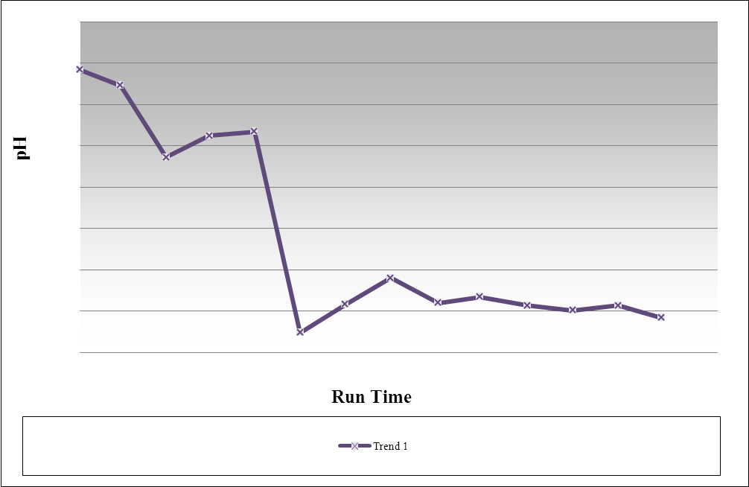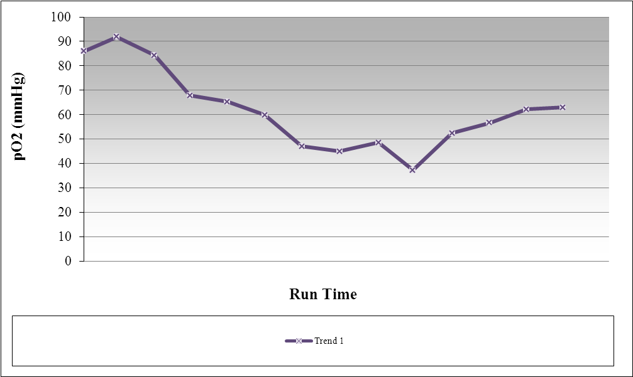

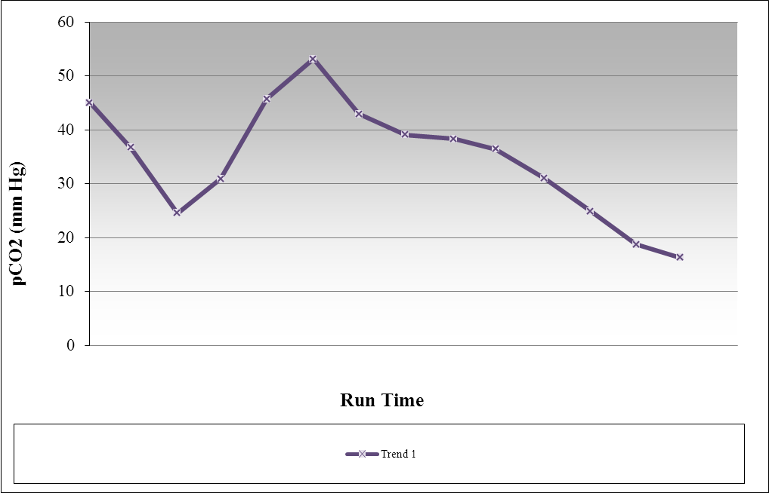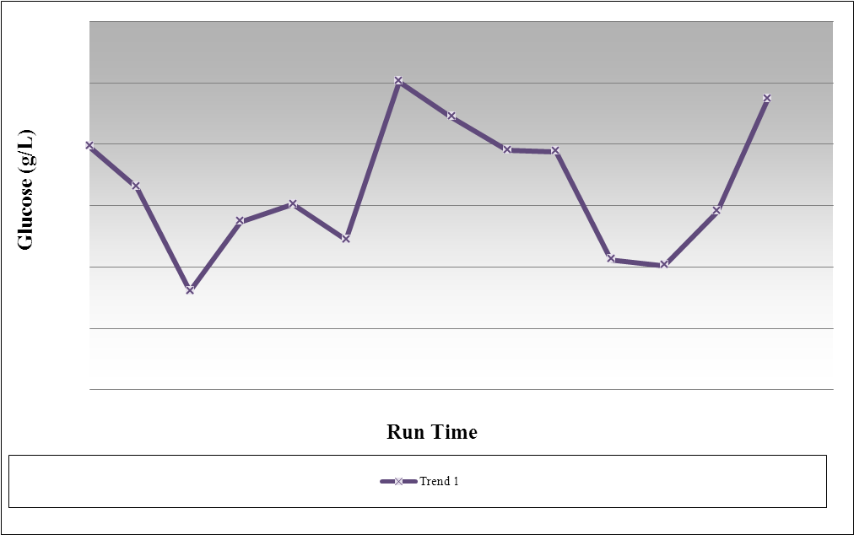

1. What would be acceptable ranges of units for each of the graphs:
a. pH -_____________________________________________
b. CO₂-__________________________________________________
c. O₂-____________________________________________________
d. Glucose- _______________________________________________

2. The graphs supplied by Biogen Idec measure other limiting factors such as pH, CO₂, O₂, and Glucose levels on mammalian cell cultures. Explain below how each of these other limiting factors can influence the growth of cells.
a. pH – ___________________________________________________________
b. CO₂- _________________________________________________________________
c. O₂- __________________________________________________________________
d. Glucose-_______________________________________________________________

3. How does each of the following limiting factors affect the mammalian cells as depicted in the graphs?
a. pH – ___________________________________________________________
b. CO₂- _________________________________________________________________
c. O₂- __________________________________________________________________
d. Glucose-_______________________________________________________________

4. Make predictions as to how each of the limiting factors may affect yeast cell growth similar to those in the experiment.
a. pH – ___________________________________________________________
b. CO₂- _________________________________________________________________
c. O₂- __________________________________________________________________
d. Glucose-_______________________________________________________________

5. What can be concluded with regards to limiting factors such as those tested and presented in the Biogen Idec graphs and cell culture development?

6. What are your final thoughts with regards to the types of cells used for Biotechnology’s cell culture development and does cell type matter?

