Title | Saving Those Who Save Us: Exploring the use of sensors with data visualization
Introduction | Emergency rescue teams often experience a number of physiological stressors depending on the scenario they find themselves in. These stressors can take a variety of forms, including but not limited: high/low temperatures, low lighting, smoke, dangerous gasses, etc. These dangers exist for both human responders as well as search and rescue animals such as dogs. Besides the health risks, training the responders to work under such conditions is an expensive undertaking for search and rescue organizations. The use of environmental monitoring sensors can help reduce the risk of team member injury or loss, in terms of both overall health as well as monetary expenses, if utilized appropriately.  In this project, students will explore the basics of different types of sensor devices using the Texas Instruments SensorTag. They will consider how sensors can be used to protect lives of responders and investment of the organizations. Students will research and design their own experiment examining how environmental factors differ using the SensorTag to collect data and interpret it with a spreadsheet application such as Microsoft Excel or Google Sheets.
Real Science Application | The One Health Initiative promotes the interconnectivity between people, animals and our environment. Various organizations such as the ASSIST Center at North Carolina State University are actively involved in researching and designing non-invasive wearable devices using nanotechnology to monitor an individual’s health, as well as the environment. These devices can be used to help ensure those individuals working in dangerous environments can protect themselves so they can continue to serve their community.  In examining how sensors operate, students will explore the cutting edge of research and gain a better sense of how popular off the shelf sensor devices, such as the popular FitBit, operate as well as the purpose such devices can take on. They will also gain a better understanding of designing scientific experiments and reporting their findings in an easy to understand, visual representation.

Curriculum Alignment | This section contains the curriculum alignment of the lesson to the North Carolina Career and Technical Education (CTE) competency and objectives.
  CTE Content Area | Grade Level | CTE Unit Competency | CTE Objective Statements
  Scientific Visualization | 9-12 | Unit E:  Synthesize data for scientific & technical visualization | Objective 105.02  Describe the steps of a design brief
  Objective 105.03
  Interpret data for use in charts & graphs
  Objective 105.04
  Apply data to make the appropriate graph
  Probability & Statistics | 9-12 | Interpreting categorical & qualitative data | CCSS.MATH.CONTENT.HSS.ID.A.1  Represent data with plots on the real number line (dot plots, histograms, and box plots)
   |  | Interpreting categorical & qualitative data | CCSS.MATH.CONTENT.HSS.ID.B.6  Represent data on two quantitative variables on a scatter plot, and describe how the variables are related
Learning Outcomes | Students will write an experimental design brief  Students will collect data using sensor devices  Students will interpret and report their results using the appropriate chart
Time Required and Location | Seven 50 minute class periods  Depending on activity selected, some students may be out of the classroom while taking measurements but the majority of the time will be spent in the classroom.

Materials Needed | Teacher List  - 1 Texas Instruments SensorTag cc2650 per group  - Computer access for each student in class  - Hall passes for students leaving the room to collect data  Student List  - Design brief worksheet  - Sensors reflection worksheet  - Data collection worksheet  - Data Visualization rubric  - Computer access with spreadsheet application and internet access  - 1 Apple or Android Smartphone per group  - BLE TI SensorTag app
Safety | Students will be using basic sensors on the devices and will not have access to any dangerous chemicals or substances. Even though the SensorTag is in a protective case, make sure to discuss proper handling of the device with students and make sure they understand that the device is not waterproof, so it should never be placed in water.
Participant Prior Knowledge | These activities are designed to be part of a larger unit on data visualization. Students should already be familiar with creating charts and graphs using spreadsheets, effective use of Internet search techniques, basic scientific method and different environmental measurements including light, magnetics, humidity, pressure, motion, and temperature.
Facilitator Preparations | Become familiar with the TI SensorTag. Information is easily accessible on the Texas Instruments website at: http://goo.gl/t8YPmK. Also familiarize yourself with the BLE SensorTag smartphone app. The app is available for both Android and Apple devices and can be downloaded from the Google Play and Apple stores for free.  Verify district policy to determine if there are any rules about students downloading apps to their phones or if parental consent to do so is required.  - Determine how the students will be assigned to groups. It is recommended to not use more than three students in any group.  Review lecture material on design briefs prior to data collection.
Activities | DAY 1: BACKGROUND RATIONALE AND EXPLORATION  Teacher Note: Students will need Internet access for part of the day’s exercise. Make sure to secure a space if you lack a computer lab in your classroom before starting the lesson plan.  Explain to the class that sensor devices can be used to monitor any number of different environmental measurements as well as take measurements from an individual’s physiology. Have students privately write down what sensors they think are currently available and what kinds of factors they are currently used to monitor. [5 minutes]  Once completed, discuss what the students wrote. Questions should include items such as:  - What is a sensor device?  - Do you use any sensor devices?  - Where can you find sensor devices in your daily life?  - What kind of sensor devices did you think of?  - What careers use different kinds of senor devices?  - What kinds of devices to those careers use and how do you think they use them?  Discuss as many sensors and uses as possible, recording student responses to see how many different ideas the students can come up with.  With your list in hand, explain that the class will be working with a sensor device known as the Texas Instruments cc2650 SensorTag to collect and analyze data for this lesson. The SensorTag supports a variety of different environmental measurements including light, magnetics, humidity, pressure, motion, and temperature. Have students answer the following question: looking at the list you came up with and knowing what the SensorTag monitors, what kind of experiments/uses for the SensorTag can you think of? Discuss this information the students find. [5 minutes]  Students will finish the first day doing Internet research on sensor devices related to the options available on the SensorTag device (light, digital microphone, magnetic sensor, humidity, pressure, accelerometer, gyroscope, magnetometer, object temperature, and ambient temperature) as well as the kinds of environmental measurements one can collect with them. As they conduct their online research, they should focus on ways the class could use the SensorTag specifically to conduct an experiment at school. This will be the root of their decision on what kind of data they will collect for the remainder of the lesson. So thorough research is important as well as considering what the Sensor Tag can measure.  Recommend that students alone or in small groups to examine the following websites as part of their research: ASSIST Center at NC State, the One Health Initiative, Center for Disease Control (CDC), and Federal Emergency Management Agency (FEMA). Note - An easy way to focus a search in Google is to include the site search extension (example Google entry – using sensors to monitor health site: cdc.gov). Doing this will limit the returned links to information only posted on the CDC’s website. Use the Conducting a Smarter Internet Search infographic located below to help students effectively search.  Remind the students to bookmark or write down the addresses of the websites found as they will need to return to them. As the students are exploring sensors, the teacher should walk around the room assisting by answering questions and making sure they think realistically in terms of what can be measured in their individual classroom.  Before students leave, poll them for who has access to a smartphone so groups can be assembled prior to the next class.  DAY 2: EXPLORE/EXPERIENCE SENSOR DEVICES  Students will spend the day learning the basics of the TI SensorTag. Begin by pairing students with each other. Although this can work with larger groups, it is not recommended to put more than four students in a group and pairs work best.  Once paired up, at least one member of each group will need to install the BLE SensorTag app on their cell phone. To do this, they will need to download it from either the Apple Store or the Google Play Store, depending on what kind of phone they are using. The app installs like any other app that is downloaded by simply following the prompts on the screen. Cost is free but it is recommended that you let the students’ parents know that although it does not use any data to run the app, downloading it will. Because of this, it is advised to request students install the app when they are to a wi-fi network, such as from home.  Next, students will need to pair their SensorTag with the app on their phone(s). Pairing the app and SensorTag requires the use of a Bluetooth connection. The teacher will need to walk students through the process. Begin by turning on the SensorTag using the power button on the side. Students should see a flashing light on the device once it is powered on. Next, open the app on the phone. To find the device, click the Scan button in the app window. This should find the SensorTag. Once the SensorTag is identified, press Connect to pair the devices. Once a connection is made, the app will automatically begin displaying the data being collected by the SensorTag.  Important Note – If SensorTag devices are too close to one another, the app may find multiple devices. This may cause some confusion as the names on the devices cannot be altered and are not clear as to what name identifies which device. It will also find other nearby Bluetooth enabled devices. Students may want to try connecting in the classroom but disconnect and re-establish a connection once they have moved away from other students, such as into a hallway.  Explain to the class there are 10 different kinds of sensors on the device (light, digital microphone, magnetic sensor, humidity, pressure, accelerometer, gyroscope, magnetometer, object temperature, and ambient temperature) that can be used for measuring different environmental factors.  Allow the students to independently explore the sensors and how the readings appear in the BLE SensorTag app. Explain that they should test out the different kinds of sensors such as light levels, ambient temperature, IR temperature and so forth. They should examine how the readings are reported on the screen. Also, ask them to see if they can determine how to alter the settings of various sensors including the kind of measurement and the frequency the sensor records readings from the environment.  While students are exploring how the device and app work, you should move around the room to assist any student who is having difficulty connecting to the SensorTag or address any questions that students might have about the sensors or interpreting the readings they are getting as they explore.  Near the end of the period, bring the class back together as a whole to share what they experienced and learned about the sensors and the TI SensorTag device and how it relates to their Internet research from the previous class. [10 minutes]  DAY 3: UNDERSTAND DESIGN BRIEFS  Using the lecture material on Steps of a Design Brief (objective 5.02) provided as part of the NC State Scientific & Technical Visualization I curriculum, discuss how to create a design brief and why they are important. Remember, a design brief is a plan for how you will conduct your project or experiment. Make certain to address the various components: title (example - the effect of the independent variable on the dependent variable), hypothesis, definition of variables, and how the variables will be measured.  Hand out the Design Brief Template and review each of the sections with the class. Answer any questions students might have about the template or how to use it to effectively create their design brief using this template.  Students may select to answer from one of the following options using the TI Sensor for data collection:  - Temperature differences in different locations around campus  - Amount of light present in different locations around campus  - Effects of different techniques used to alter an object’s traveling of a set distance  Students have the rest of the period to fill out the design template for their experiment and begin to research their topic and how they will test their selected topic. Circulate around the room responding to questions about the SensorTag’s capabilities and writing the brief. Any student who finishes their design brief early can continue exploring the different sensors on the SensorTag.  Prior to the end of class, collect each group’s design brief. These initial design briefs will need to be checked prior to the next day’s lesson so you know if any special equipment or design alterations are needed prior to data collection.  DAY 4: DATA COLLECTION  Begin the class by reviewing the design briefs submitted the day before. Make sure that all students know where the materials they need are located and get them started on data collection. If there are any students whose design brief needs adjustment, speak with those groups and explain what they need to alter before they can collect their data. [5 minutes]  You should move around the students as they collect data, answering questions about how the sensor tags work, how to best collect data and how to record data. Note – Remember, based on the question they are answering, some students may be collecting data outside the classroom or building. The teacher may want to give the class a five minute warning to start gathering resources in preparation for the end of class..  DAY 5 & 6: WRITING THE REPORT  Begin the class by reviewing what has been completed up to this point and addressing any questions that students may need answered. Students should have already:  - Explored sensor devices in the form of the TI Sensor Tag  - Written and submitted a short design brief using the provided template  - Collected data using the provided template (provided below)  Today’s focus is on creating the appropriate chart based on the lecture from earlier in the unit about how to use spreadsheets to create data visualizations. Begin by reviewing what different kinds of charts are used for:  - Pie – parts/percentages of a whole  - Bar/Column – comparing categories of data  - Line – examining changes over time  Each student should create their own chart based on the data they collected. They will enter their data into a spreadsheet application and select the appropriate chart type based on the question they examined. Students need to make certain to include appropriate titles and labels so the reader understands what their chart is about.  Students should also spend time writing a short, reflection describing what they did, what they learned about sensors and showing the appropriate chart for their data. This could take the form of a reflective essay, a formal research report, a blog post, or any other method that is appropriate for your students. But, whatever the format used, the students should be able to discuss the procedures they used, what sensor was selected and why, what the variables being tested were (dependent and independent), show their chart and discuss what they learned from this exercise.  By the end of the second day, students should submit their finished reflection including the charted data. It is recommended that students submit digitally but using printed reports can work as well if the teacher prefers.  DAY 7: SHARING RESULTS AND EXPERIENCE  This day is all about sharing what the students learned. There are a couple of recommended ways to accomplish this:  - Teacher led: Project individual projects on your screen/board – Discuss them one at a time, what was done well, what problems did the groups experiences, what could be improved?  - Poster sessions – Groups create a simple poster explaining what they did including their report and data visualization. Students can then move around the room, reviewing each poster and adding comments. If this option of sharing is selected, the teacher will need to allot additional time for creation of the posters or require students to make them outside of class for homework. Depending on the period length and the students involved, it is recommended to allow one to two days for poster creation.  Student presentations – Groups can make public presentations in front of the class explaining their research process and results.
Assessment | A rubric (1) will be used to assess student learning about design briefs, experimental design and data visualizations.  See the following rubric at end of the unit plan:  - Data Visualization Rubric

Critical Vocabulary | Spreadsheet – An electronic document in which data is arranged in the rows and columns of a grid and can be manipulated and used in calculations  Graph – A diagram showing the relation between variable quantities  Pie Chart – A type of graph in which a circle is divided into sectors that each represent a proportion of the whole  Line Chart – A type of graph which displays information as a series of data points called 'markers' connected by straight line segments; commonly used to show changes over time  Column/Bar Chart – A graph using parallel bars of varying height/lengths which illustrates comparative data between categories  Title – Describes the data the chart is symbolizing  Legend – An explanatory list of symbols on a chart  Axis – The reference lines in a coordinate system; X is horizontal; Y is vertical  Experimental Design – The design of any information-gathering exercises where variation is present, whether under the full control of the experimenter or not  Data – The actual value of what is being measured  Hypothesis – A proposed explanation made on the basis of limited evidence as a starting point for further investigation  Dependent Variable – The number or value you are measuring  Independent Variable – The predetermined number or value that does not change  Sensor Device – A device that detects and responds to some type of input from the physical environment
Community Engagement | Examples of engagement (this is by no means an exhaustive list, rather a few ideas)  - Sharing student projects during an open session either during lunch or one evening where students/families can do a gallery walk and ask questions about the project  - Students could partner with other schools to collect and analyze data, then compare and contrast the results between schools  - Share student work with guest speakers you invite from industry
Extension Activities | Advanced students can be encouraged to explore a personal choice for sensor research outside the three options previously given.

Modifications | When designing group assignments for this lesson, make sure to pair students identified as needing modifications or who struggle with English together with those who do not.
Alternative Assessments | While not preferable, individuals could be assessed as an overall group as opposed to individually. The same rubric may be used for this.  One alternative would be to ask each group member to complete a reflection on the activity as a group. Sample questions might include:  - What grade do you think you deserve and why?  - Is there anyone in the group that deserves extra credit above the group average and why do you feel they deserve it?  - Is there anyone in the group who does not deserve the group’s full credit and why?  Based on the responses, one could use this information to generate different grades for each group member.
References | Background Information  Unit E: Data Visualization. (Summer, 2005). In Trade and Industrial Education: 7901 Scientific & Technical Visualization I and Technology Education: 8006 Scientific & Technical Visualization I (Class Lecture ed.). North Carolina Department of Public Instruction: Career & Technical Education. Lecture material provided as part of the Career & Technical Education (CTE) Scientific Visualization curriculum. For more information on this material, please check the website for NCDPI at http://www.ncpublicschools.org/cte/program-areas/technology/programs  One Health Initiative will unite human and veterinary medicine. (n.d.). Retrieved July 8, 2015, from http://www.onehealthinitiative.com/  NC State ASSIST Center. (n.d.). Retrieved July 8, 2015, from http://assist.ncsu.edu/  SimpleLink Multi-Standard CC2650 SensorTag Reference Design. (n.d.). Retrieved July 8, 2015, from http://www.ti.com/tool/TIDC-CC2650STK-SENSORTAG  Information on Sensor Devices  List of Sensors. (n.d.). Retrieved July 8, 2015, from https://en.wikipedia.org/wiki/List_of_sensors  Environmental Monitoring. (n.d.). Retrieved July 8, 2015, from https://en.wikipedia.org/wiki/Environmental_monitoring  Wearable Technology. (n.d.). Retrieved July 8, 2015, from https://en.wikipedia.org/wiki/Wearable_technology  Get The Enterprise Wearables Report. (n.d.). Retrieved July 8, 2015, from http://vandrico.com/wearables
Comments | This lesson can serve as a final project for Unit 5 on data visualization to demonstrate overall understanding of techniques and information.  This lesson also helps to reinforce the Common Core Math Standards for Probability and Statistics by reinforcing the student’s ability to collect, summarize, and interpret measured variables.  Templates below need to be reformatted to allow space for students to write. Space was compressed to fit in this document.
Author Info | Kenan Fellow: Robert Bourgeois  - Mr. Bourgeois is a Career and Technical Education teacher at Durham School of the Arts in Durham, NC. Certified in both Business Education and Technical Education, his main focus is in the following curriculums:  - Scientific Visualization  - Game Art & Design  - Advanced Game Design  - CTE Advanced Studies  - Multimedia & Webpage Design  - Email – robert.bourgeois@dpsnc.net  Mentor: Dr. Jesse Jur  - Dr. Jur is an assistant professor at the North Carolina State University College of Textiles. His research in the field of nanotechnology focuses on the development and modification of unique nanostructures of conductive and insulating materials by atomic layer deposition. These nanostructures are used in various applications including textiles and photovoltaics.  - Email – jsjur@ncsu.edu

Lesson Resources Below:

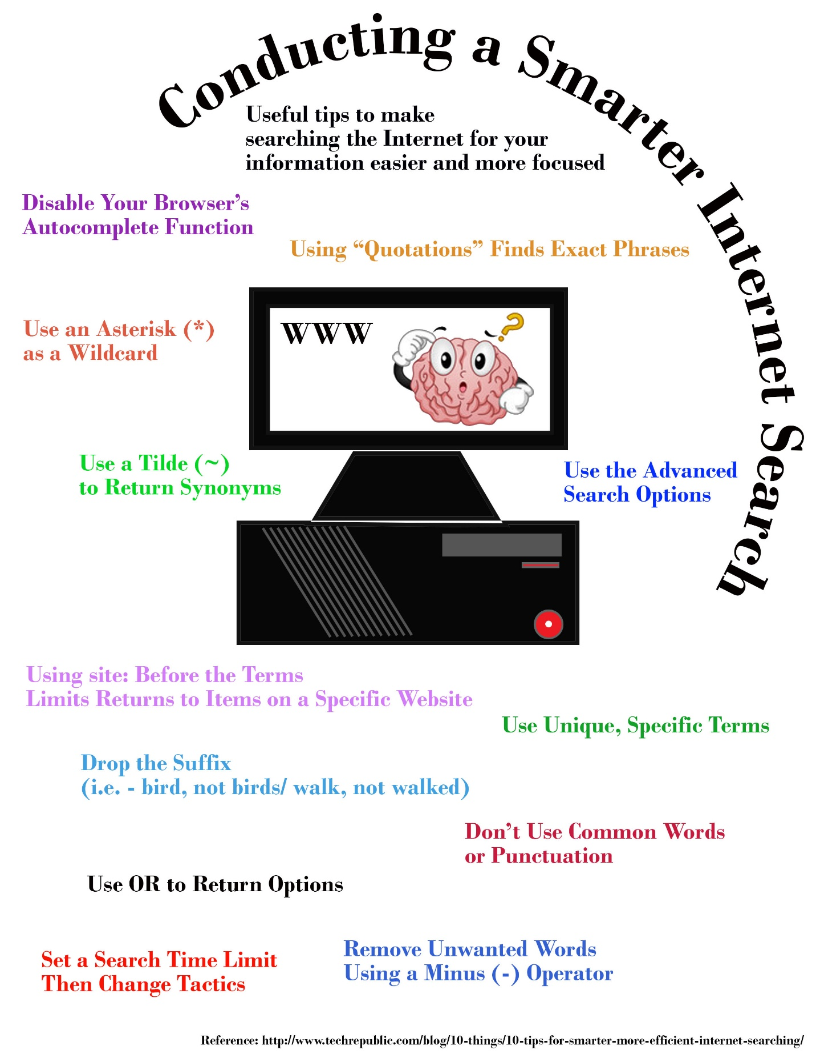

Design Brief Template
DIRECTIONS: Please fill out of the below areas CLEARLY

- TITLE: (The effect of _________________ on _____________________).
  - Example: The effect of different light sources on the growth of plants.

- HYPOTHESIS: Use an if/when... then... statement. State the cause & effect relationship between the IV and the DV. The hypothesis must be testable.
  - Example: If we change the light source from a natural to artificial source, then we will observe a difference in the growth of the plants.

- INDEPENDENT VARIABLE: List what is the cause agent? What are you changing?
  - Example: Light sources will be changed: sunlight, blue light, red light, yellow light, white light

- DEPENDENT VARIABLE: (What is being measured?)
  - Example: Height of plants

- CONTROL GROUP: (What is the experimental group being compared to?)
  - Example: Plant growth using sunlight

- EXPERIMENTAL CONSTANTS: (Variables not altered during the experiment)
  - Example: Temperature, watering schedule, etc.

- EQUIPMENT NEEDED: (List ALL items needed to successfully complete the experimental design)

SKETCH OF EXPERIMENTAL SET-UP, clearly labeled:

Data Collection Worksheet
DIRECTIONS: Use this worksheet to assist you in collecting data. Fill in each cell above as indicated. You should collect a minimum of 10 sensor readings as part of this process. Use more than one sheet if necessary.
Experimental Design | Collection Location | Sensor Reading | Notes:
Hypothesis:
Variables:
Sensor Used:

Student Name: ____________________________________________

Data Visualization Rubric
Criteria | Above Average  20 points | Average  15-19 points | Below Average  8-14 points | Lacking  0-5 points
Descriptive Title | Title is appropriate for the project and descriptive encouraging further exploration | Title is present but does not catch the reader’s attention | Variables listed incorrectly in title making it confusing | No title present
Hypothesis | Hypothesis uses if/then statement to show cause and effect, is testable and involves deeper reasoning skills than expected | Hypothesis uses if/then statement to show cause and effect and is testable | Hypothesis uses if/then statement but is untestable | No hypothesis is present
Variables, Control Group & Constants | Explains the independent and dependent variables, explains the control group, discusses experimental constants and explores the relationships between the variables | Explains the independent and dependent variables, explains the control group and discusses experimental constants | Contains independent and dependent variables but does not discuss the control group or experimental constants | No variables discussed
Writing Skills | Writing contains NO spelling, punctuation or grammatical errors | Writing contains no more than three (3) combined spelling, punctuation, and/or grammatical errors | Writing contains no more than six (6) combined spelling, punctuation, and/or grammatical errors | Writing contains more than six (6) combined spelling, punctuation, and/or grammatical errors
Data Visualization (Chart) | Chart clearly simplifies understanding of the collected data. Correct chart is selected, descriptive title and labels are included, data plotted on appropriate axes | Chart clearly simplifies understanding the collected data. Correct chart is used but there is some ambiguity of what the data relates to (title or labels lack good description or data on incorrect axes) | Incorrect chart was used to display data but all information is labeled appropriately | Incorrect chart was used to display data and lacks appropriate information (title, labels, etc.)
Submission Checklist
Design Brief:  Student Name: __________________________________________ | ☐
Sensor Reflection: | ☐
Data Collection: | ☐

Data Visualization Lecture Slides

